**Supply List *5th Grade * 2023-24**

**Please bring $25.00 for additional classroom curriculum projects. This fee does not include our 5th grade field trip activities currently in the planning stages.**

**1 composition notebook**

**1 large box of tissues**

[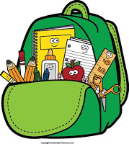](https://2.bp.blogspot.com/-VIXUEsnSPfY/W1oiVfz0vhI/AAAAAAAABNI/KHGdG74cBUc8_Z5LsUUztpxFLybN1PJDgCLcBGAs/s1600/image1.jpeg)

**1 pair scissors**

**1 white crew sock(We use the sock as an eraser)**

**2 pink erasers**

**Colored pencils**

**1 large box Ticonderoga pencils (These do not break as easily in the sharpener as do other brands.)**

**2 ultra fine point black Sharpies**

**2 fine point black Sharpies**

**Small pencil box (to hold colored pencils, scissors, erasers, and sharpies within their cubby space)**